Volunteers’ Handbook
Contents

Welcome to Stretham Old Engine (SOE) 2
Introduction to SOE 3
Check list 4
Organisational structure at SOE 5
Expenditure reimbursement 6
Health & Safety 7
Lone working and access to site 7
Health & safety – reporting concerns 7
Health & safety – working with chemicals 7
Health & safety – working at heights 8
First Aid on site 8
Storage of personal details 9
Volunteer application information 9
Volunteer application form 10

Welcome to Stretham Old Engine (SOE)

SOE is run by The Stretham Engine Trust, registered charity number 299105. The Trustees are responsible for the overall governance of the Engine, subject to regulations prescribed by the Charity Commission, in particular, demonstrating sound and transparent financial accountability. The Trustees are also required to ensure that relevant legislation is upheld, such as the laws pertaining to Health and Safety and Data Protection.

The Trust’s aim is to preserve this historic building and artefacts, in compliance with its status as a Grade 2* Listed Building and a Scheduled Ancient Monument, for the interest and education of present and future generations. Thank you for volunteering to help at SOE, without the support and efforts of our volunteers we would not be able to ensure the future of this marvelous piece of history.

This handbook aims to tell you what you need to know about volunteering at SOE. As the network of volunteers at SOE grows and circumstances change this handbook will be updated accordingly. Please check the SOE website for the latest version of this document. www.strethamoldengine.com/volunteering

Introduction to SOE

SOE was built in 1831 and was one of the earliest drainage engines in the Fens. It is the last complete survivor of more than 100 such engines built throughout the area in the 19th and 20th centuries. Although now turned by electricity, we aim to provide visitors with the opportunity to experience the sounds and demands of those bygone days.

Whilst the massive 27 foot high Beam Engine is the ‘Jewel in the Crown’ here at SOE, a collection of other, often unique, engines and pumps illustrate the story of steam and drainage. An old hand operated Archimedean screw pump can be seen as well as a huge Mirlees marine diesel engine coupled to a centrifugal pump, illustrating the predecessors and successors of the ‘Age of Steam’. A wonderful collection of ‘dyking’ hand tools, alongside other local artefacts give a rounded story of the working life of our forebears.

Check list

For insurance purposes we need to have received this complete form before any volunteer work on site can be started.

Please tick to confirm that you have read and understood the sections below. Once you have read each section and completed the tick list please remove this page, sign and date it and return it to the Health & Safety Supervisor, keeping a copy for yourself.

Organisational structure at SOE
Expenditure Reimbursement
Health & safety - lone working and access to site
Health & safety – reporting concerns
Health & safety – working with chemicals
Health & safety – working at heights
First Aid on site
Storage of personal details
Volunteer application information
Volunteer application form (returned)

I, the undersigned confirm that I authorise the Stretham Old Engine Trust (hereafter referred to as ‘the Trust’) to keep my data securely and only use it for the purposes of communication with me as a volunteer at the Trust. I understand I can ask to see the data that the Trust holds on me, and can also ask for my data to be removed from the Trust’s records at anytime, in accordance with GDPR.

Name:

Signed: Date:

Organisational Structure at SOE

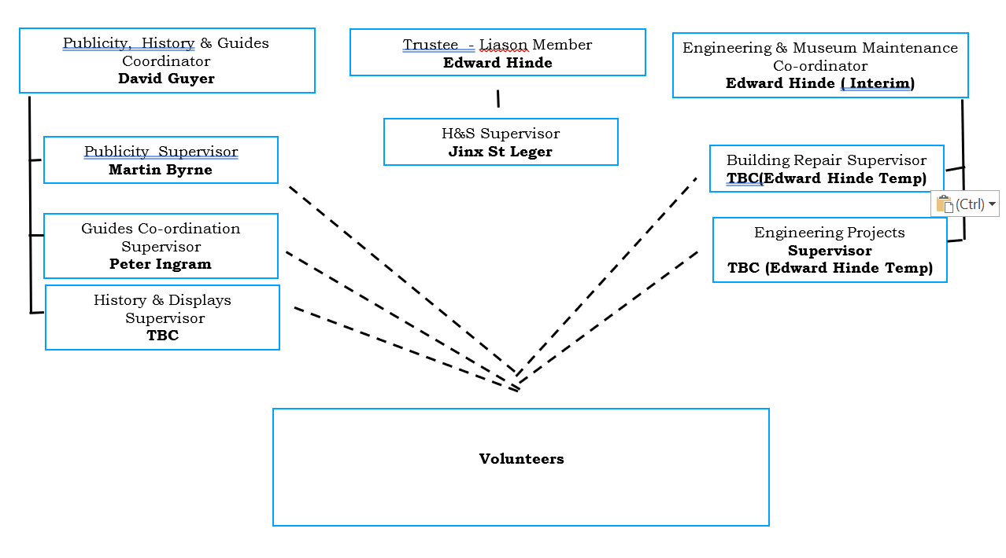

Expenditure Reimbursement

Before incurring any expenditure on behalf of the SOE you must first obtain the authorisation of your Section Head. Claims for reimbursement must be submitted using an Expenditure Reimbursement Claim Form, supported by relevant invoices/receipts and approved by your Section Head. Regrettably, the SOE cannot guarantee the reimbursement of any unauthorised expenditure.

The following form can be found at www.strethamoldengine.com/volunteering

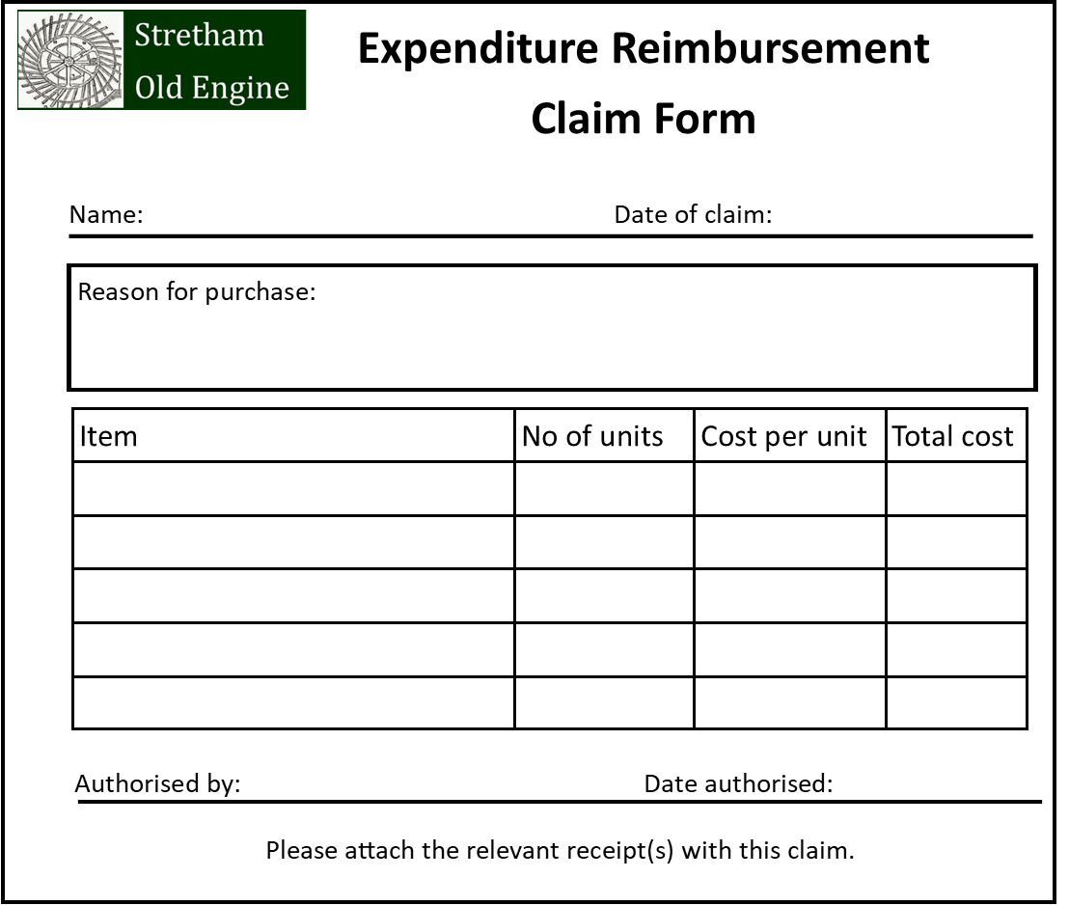

Health & Safety

Due to the remote location and nature of the building special care and attention needs to be taken when working at SOE. Failure to do so may result in the Trustees reviewing whether a volunteer may be allowed to continue working on site.

Virtually all aspects of work and activities need be assessed prior to commencement, and, local certificates issued. All volunteers must confirm in writing that they have read and understood this paperwork. Copies of the certificates must be displayed at the Engine and be available to those who wish to see them. These documents are subject to inspection by the Local Authority and are required to be regularly reviewed and kept up to date.

Lone working and access to site
Lone working is not permitted on the SOE site, due to its location and nature. It is recommended that volunteers should undertake site work in groups of three to ensure that there is adequate supervision and that everyone on site is kept safe.

At times the Trustees may deem it necessary to limit the number of volunteers/people on site and volunteers are requested to adhere to this request to lower the potential risks involved.

Members of the public are not permitted on site unless by prior agreement with your section head.

Some volunteers who have agreed to the terms and conditions outlined in the volunteer handbook will have a set of keys to SOE. Under no circumstances must these copied without permission from the Trustees or be given to non-authorised persons. Only volunteers who have signed the volunteer agreement can be keyholders going forward from 30th November 2021.

Health & safety – reporting concerns
Whilst on site if any health or safety concerns become apparent, please inform the other volunteers on site in the first instance and email the Health & Safety Supervisor at HSSupervisor@strethamoldengine.com

Health & safety – working with chemicals
Chemicals such as fuel, lubricants and cleaning fluids are kept in designated storage containers around site. Before use please ensure that you are familiar with the health and safety practices and first aid treatments recommended when using them. All chemicals should be kept out of reach of the public and should be stored in the appropriate place after use.

Health & safety – working at heights
Only certified ladders (those with an in-date ticket attached) should be used for working at height. Ladders should be appropriately secured before use and may only be used under the supervision of another volunteer.

First Aid on site
There is a first aid kit on the right-hand wall in the engine room. If you need to give any first aid please fill in an accident report sheet, which can be found in the counter in the engine room, indicating which items have been used so that they may be replaced. First Aid incidents should also be reported to the Health & Safety Supervisor at HSSupervisor@strethamoldenginge.com. Please note all personal data will be stored by SOE in compliance with the GDPR 2018.

Storage of personal details

All personal details given to SOE as volunteer are held securely offsite in compliance with the GDPR 2018.

If you wish to have your data removed from SOE’s records please contact us at GDPR@strethamoldengine.com and your data will be removed as soon as possible.

Volunteer application information
The volunteer application form can be found on page 10 of this handbook and also on SOE’s website under www.strethamoldengine.com/volunteering.

As part of our safer recruitment and application process we may ask potential volunteers to undergo a standard Disclosure and Barring Service (DBS) check, the costs of which are paid for by SOE, not the volunteer. Three forms of ID are required to complete a DBS check. Permitted forms of ID include, but are not limited to: birth certificate, driver’s license and/or passport. Further information on the DBS check can be found at https://www.gov.uk/government/publications/dbs-identity-checking-guidelines/id-checking-guidelines-for-dbs-check-applications-from-3-september-2018

Once checked by the appointed Trustee a copy of the DBS certificate will be held on file with the volunteer’s application and the original returned to the applicant.

If you already have a DBS certificate and are subscribed to the online update service you can chose to give us permission to view your certificate online instead of undergoing a new check.

Volunteer Application Form
